Case study 1: Intelligent Automation in agriculture.
Case study 2: Intelligent Automation in warehouse.
Case study 3: Intelligent Automation in packing.
Natural Language Processing (NLP) is central to modern automation in customer service, chatbots, and text analytics. In customer service and chatbots, NLP powers intent classification (detecting what a user wants), entity recognition (pulling out names, dates, product IDs), dialogue management (keeping context across turns), natural language generation (producing fluent replies), and—when voice is involved—automatic speech recognition (ASR) and text-to-speech (TTS). Typical applications include automated FAQ answering, guided troubleshooting, order tracking and updates, appointment scheduling, billing inquiries, proactive notifications (shipment delays, subscription renewals), and customer on-boarding flows. Chatbots range from simple rule-based bots that use keyword matching and canned responses to advanced conversational agents using transformer-based models (BERT/RoBERTa for NLU; GPT-style or retrieval-augmented generation for responses) with multi-turn context and slot filling for transactional tasks. In text analytics, NLP is used to mine unstructured customer interactions—emails, chat logs, social media, reviews—for sentiment analysis, topic modelling, trend detection, root-cause analysis, churn prediction, competitive intelligence, and compliance monitoring (e.g., detecting regulatory violations or sensitive information leaks). Combining text analytics with dashboards and alerting enables service teams to prioritise issues, identify recurring defects, and tailor product improvements.
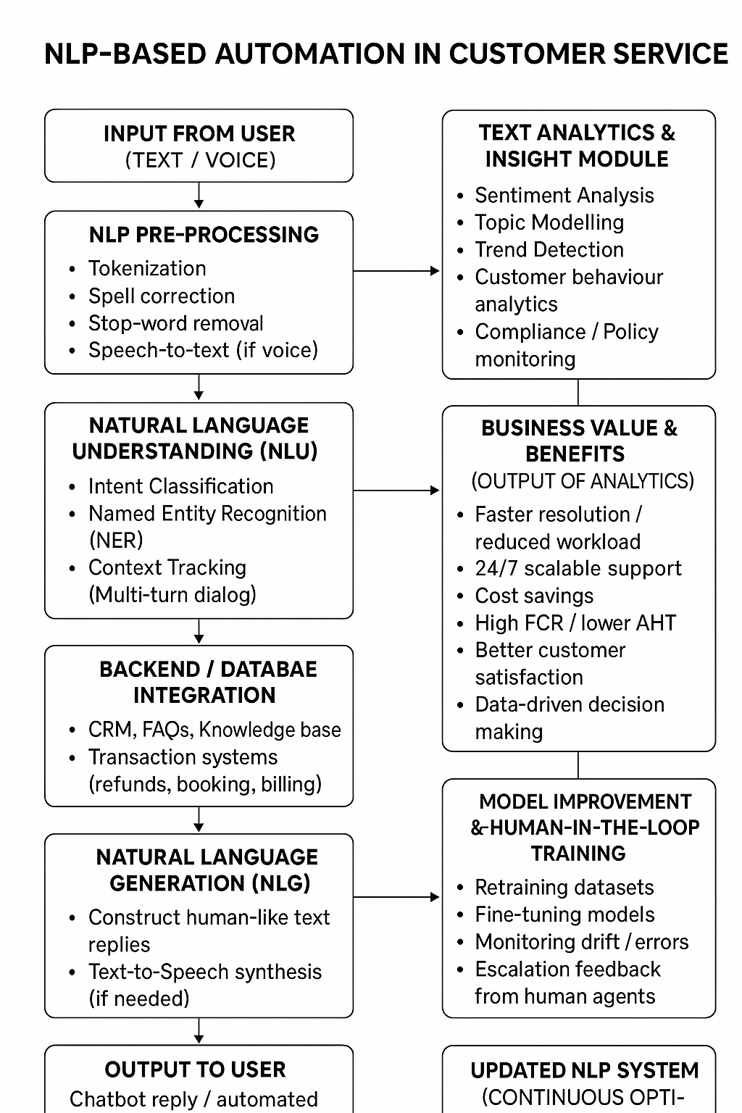

Benefits of Deploying NLP-Based Automation (Key Points)
- Provides 24/7 availability and handles large volumes of queries efficiently.
- Reduces operational cost by automating first-line support and lowering agent workload.
- Improves customer experience through instant replies, consistent answers, and personalization using past interaction data.
- Enhances business intelligence by converting unstructured text into insights (sentiment, topics, intent trends).
- Ensures better quality control and compliance by applying rules consistently and maintaining audit logs.
- Hybrid bot–human workflow increases first-contact resolution by escalating complex cases with preserved context.

Challenges in NLP-Based Automation (Key Points)
- Difficulty handling slang, misspellings, dialects, and out-of-domain queries.
- Maintaining context in long multi-turn conversations is still error-prone.
- ASR errors reduce accuracy in voice-based systems.
- Struggles with sarcasm, ambiguity, and multi-intent messages.
- Data privacy and regulatory compliance risks due to PII handling (GDPR, CCPA).
- Potential for bias, inappropriate outputs, or hallucination, affecting trust.
- Integration with legacy systems (CRM, backend APIs) can be technically challenging.
- User resistance due to trust issues, impersonal interactions, or poor handoff.
- Requires continuous model monitoring, retraining, and maintenance.

Best Practices and Mitigations (Key Points)
- Use human-in-the-loop workflows: automation for routine queries, escalation for uncertain or sensitive cases.
- Adopt retrieval-augmented generation (RAG) to ground responses and reduce hallucination.
- Fine-tune models on domain-specific datasets and use transfer learning.
- Implement strong preprocessing, spell correction, language detection, and multi-language support.
- Enforce privacy safeguards: PII redaction, encryption, minimal data retention, federated learning if needed.
- Reduce bias via diverse datasets, fairness evaluation, and human review.
- Provide clear fallback responses (“I’m not sure—connecting you to an agent”).
- Track key metrics: intent accuracy, containment rate, CSAT, FCR, AHT, escalation rate.
- Use CI/CD pipelines, model versioning, canary releases, and continuous monitoring.
- Ensure low latency architecture with scalable microservices and caching.

